Title of the manuscript

Lovely Euphrasie-Clotilde1, Jack Molinié1, Tony Feuillard1, Francenor Brute1

1Department de physique, Laboratory of Research in Geoscience and Energy (LARGE), University of Antilles, Pointe-à-Pitre, 97 110, Guadeloupe

*Correspondence to*: lovelyeuphrasie@hotmail.fr

**Abstract.** Please use only the styles of this template (MS title, Authors, Affiliations, Correspondence, Normal for your text, and Headings 1–3). Figure 1 uses the style Caption and Fig. 1 is placed at the end of the manuscript. The same is applied to tables (Aman et al., 2014; Aman and Bman, 2015) adipiscing elit. Mauris dictum, nibh ut condimentum pharetra, quam ligula varius est, sed vehicula massa erat ut metus. In eget metus lorem. Fusce vitae ante dictum, elementum sem non, lacinia dui. Integer tellus tortor, convallis et aliquam non, dictum vel mauris. Quisque maximus mollis dui, a mollis mauris vehicula in. Duis dui ligula, suscipit ac lectus vitae, fringilla euismod diam.

# Introduction

West African deserts are the main source of mineral dust affecting much of the Earth's globe (Zender, et al., 2003) (Schepanski, et al., 2009). Between 1000 and 3000 Mt / yr. are transported over very long distances from West Africa, to the West (the United States, the Caribbean and South America), but also to the North (Europe) and the East (Mediterranean basin and Middle East) [ (Schutz, 1980) (Koren, et al., 2006) (Kaufman, et al., 2005) (Schepanski, et al., 2009)].

The Lesser Antilles are much more affected by the « sand haze» phenomenon. Those Caribbean islands receive 28% of the Saharan dust production, while Europe receives 12% of those flows (60% are directed to the Gulf of Guinea) [ (d'Almeida, 1986) (Longueville, et al., 2009) (Institut de veille sanitaire, 2012)]. Thus, Caribbean region is in an ideal position for the study of desert dust pollution.

Size of desert dust particle are mostly less than 10 µm of diameter [ (Petit, et al., 2005) (Propero, et al., 2014)]. Compared with urban areas of developed countries, the zone of West Indies arc is characterized by weak industrial development. Anthropic pollution is therefore low. The main factor reducing air quality is presence of "sand haze", a natural pollution phenomenon. Hence, the impact of desert dust is quantifiable in PM10 (particles less than 10 µm diameter) concentration measurements recorded by the air quality networks [(Coz, et al., 2009) (Prospero, et al., 2014)]. The French legislation defined the air quality indexes by range associated with daily PM10 concentrations:

-Index 1 to 2: very good air (0-13 µg m-3)

-Index 3-4: good air (14-27 µg m-3)

-Index 5: Medium air (28-34 µg m-3)

-Index 6-7: Poor air (35-49 µg m-3)

-Index 8-9: Bad air (50-79 µg m-3)

-Index 10: very bad air (since 80 µg m-3)

From 50 µg m-3 (index 6: bad air), a spot of information related to the presence of “sand haze” is sent to the population to warn persons at risk (people with respiratory disease and asthma, cardiovascular issues…). The threshold alert is for 80 µg m-3 (Index 10: very bad air), at this level it impacts the entire population. The World Health Organization (WHO) and the European directives recommend that the daily PM10 concentration should not exceed more than 35 times the threshold of 50 μg m-3 per year. And since 2010, WHO fixed a new guideline value in annual PM10 concentration: 20 µg m-3 (which stood at 40 µg m-3 before) (Declercq, et al., 2012). In Caribbean area, only Guadeloupe, Martinique and Barbados have some measures of PM10 air quality. Studies in Barbados, Trinidad, Antigua and Guadeloupe have linked phenomenon of "sand haze" to asthma-related hospitalization increases, respiratory diseases and eye irritations. Among the local population, children have been most affected by desert dust events [(Monteil, et al., 2005)(Prospero, et al., 2005)(Prospero, et al., 2008)(Prospero, et al., 2013)(Cadelis, et al., 2014)].

Geochemical and biochemical analysis combined with satellite detection and back trajectories suggested two predominant source zones of desert dust particles: (1) the region located between Mali, Mauritania and southern Algeria (Saharan zone) ; (2) and the former Lake Chad, in the Bodélé region (Sahelian zone) [ (Prospero, et al., 1970) (Prospero & Carlson, 1972) (Schutz, 1980) (Chiapello, et al., 1997) (Ginoux, et al., 2001). (Goudie & Middleton, 2001) (Prospero, et al., 2002) (Reid, et al., 2003) (Koren, et al., 2003) (Huang, et al., 2010) (Formenti, 2011) (Clergue, et al., 2015)]. "Sand haze" events and presence of desert dust above the Atlantic Ocean are a relatively continuous phenomenon throughout the year [ (Schutz, 1980) (Ben-Ami, et al., 2012) (Prospero, et al., 2014)]. During the winter of the northern hemisphere (from November to March), the Saharan and Sub-Saharan regions (Sahel) are principally under the influence of the Harmattan, a north-eastern continental wind (Schwanghart & Schutt, 2008). The Bodélé, which has a specific topographic structure, facilitates the acceleration of winds named as “low layer jet stream”, that are responsible to 65% of source activation [ (Blackadar, 1957) (Washington & Todd, 2005) (Todd, et al., 2007) (Schepanski, et al., 2009)]. This region benefits of favorable conditions, which make it the main source of desert dust on Earth [ (Coudé-Gaussen, 1991) (Koren, et al., 2006) (Washington, et al., 2009)]. The former bed of Lake Chad consists of alluvial deposits from very fine particles-rich in diatoms, raised and transported over long distances toward the northern part of the South America (Amazonia) and the Caribbean [ (Prospero, et al., 1981) (Reid, et al., 2003) (Ben-Ami, et al., 2010) (Adams, et al., 2012) (Prospero, et al., 2014)].

During the summer of the northern hemisphere (from June to August), atmospheric configurations of the Atlantic influences the movement of Inter-Tropical Convergence (ITCZ, low-pressure air) further north. A monsoon flow (south-east maritime wind) is then created and penetrates the continent at the limit of the Saharan zone. Then, those moisture flows come into opposition with the north-east continental winds and are at the origin of important convective developments: squall lines [ (Brooks & Legrand, 2000) (Flamant, 2007) ]. They generate gust fronts responsible for raising of dust particles [ (Bou Karam, 2008) (Adams, et al., 2012) ].

Thus, the seasonal activation of these sources and the semi-annual fluctuations of the ITCZ impact the route of dust plumes over the Atlantic Ocean [ (Schutz, 1980) (Formenti, 2011) (Ben-Ami, et al., 2012) (Adams, et al., 2012) (Prospero, et al., 2014) ]. In 1980, Schutz has presented two types of dust paths correlated to the activity of Saharan and Sahelian sources: in summer, the north dust transport is mainly associated to west deserts (Mali, Mauritania); in winter, transport is located further south and linked with the dust storms of Bodélé (Schutz, 1980).

Out of regular dust season (winter and summer), the two source zones can be activated alternately or simultaneously. Indeed, during the spring and the autumn (of the northern hemisphere) desert dust events have been observed in Caribbean [ (Adams, et al., 2012) (Prospero, et al., 2014) (Euphrasie-Clotilde, et al., 2015)].

Generally, time of transport related to dust plumes to Caribbean area, has been evaluated at 5-7 days (Schutz, 1980). Recently, results of model simulations assessed time of transport in summer, at 12 days (Gläser, et al., 2015).

Nowadays, we have an increasing understanding of source emission and transport characteristics concerning the seasonal transport of dust across the north Atlantic Ocean [ (Brooks & Legrand, 2000) (Goudie & Middleton, 2001) (Chiapello & Moulin, 2002) (Prospero, et al., 2002) (Engelstaedter & Washington, 2007) (Schepanski, et al., 2009) (Huang, et al., 2010) (Adams, et al., 2012) (Gläser, et al., 2015)]. Quoted as an example, Ben-Ami (Ben-Ami, et al., 2012) identified different cycles of dust distribution over the Atlantic Ocean from an analysis based on Aerosol Optical Depth (AOD) detection [as of the MODerate resolution Imaging Spectroradiometer (MODIS), Aqua satellite]:

-The first period occurred from November to the end of March and was characterized by a southern transport route (located between 10 °E and 50 °W) directed towards the North of South America.

-The second one occurring from end-March to mid-October, has been associated with a northern transport route of mineral aerosols (between the Saharan coast and 60 °W)

-The third one related to a very weak dust presence from mid-October to mid-November.

The dust detection cycle presented by Ben-Ami was punctuated by the meteorological processes (seasonal wind regimes combined with the topography of the source regions) of Saharan and Sahelian’s emission sources throughout the year (Ben-Ami, et al., 2012).

Prospero et al. (Prospero, et al., 2014) also characterized the seasonal cycle of desert dust events on two Caribbean sites (Guadeloupe and Barbados) and the south America (Cayenne) considering the PM10 dust threshold. Based on daily PM10 concentrations from 2002 to 2012, this study showed that Caribbean stations was not affected by dust air masses in the same time. The high season dust for Cayenne start from January to May. Barbados (south of the Caribbean arc) and ~~for~~ Guadeloupe (center of the arc) ~~was~~ were more affected from May to August. However, some strong dust events occurring during March and April (spring period) impacted PM10 concentration of the three sites Cayenne, Barbados and Guadeloupe.

The present study investigated desert dust with a new approach based on the climatology of “sand haze” phenomenon through daily concentrations of PM10 measured in Guadeloupe over an 11-years period from 2005 to 2015. The aim of the study was to analyze the seasonality of the dust events, which have been previously studied only by considering the European and the WHO PM10 thresholds (50 μg m-3). Monthly analyses using back trajectories of air masses supplemented by satellite detections of AOD (MODIS) allowed us to redefine the dust seasons. Results showed that the desert dust presence was actual when daily PM10 concentration was less than 50 µg m-3. Finally, we statistically determined a new criterion separating dusty days ~~to~~ from non-dusty days in Guadeloupe. In the second part of ~~us~~ our analysis, we applied this dust threshold to realize the climatology of dust events affecting the center of West Indian arc (Guadeloupe). Thus, ~~it~~ this threshold indicates that the different dusty season present specific dusty air mass pathways, but also distinct dust event intensities and frequencies.

# Data base and Methods

## Measuring Air Quality in the Caribbean: PM10

The archipelago of Guadeloupe is located to the north of the Antilles arc (16,24°N, 61,53°W), in an area without major anthropic pollution influences (Prospero, et al., 2014). Air quality is mainly affected by the seasonal episodes of desert dust outbreaks. Since 2005, Guadeloupe has performed measurements of PM10 (Particulate less than 10 microns) supplied by the Gwad'air air quality network. These measurements are carried out every 15 minutes continuously and can be converted in hourly and daily data. The Air Quality Stations (thereafter AQS) using in this study are situated at Pointe-à-Pitre (16,2422°N; 61,5414°W, urban area) and Baie-Mahault (16,2561°N and 61,5903°W, suburban areas). PM10 concentrations are measured using the Thermo Scientific Tapered Element Oscillating Microbalance (TEOM) models 1400ab and 1400-FDMS [ (Prospero, et al., 2014) (Plocoste, et al., 2017)]. The reliability of measurement is evaluated by tests carried out under the control of the Central Laboratory for the Monitoring of Air Quality (LCSQA) for all French territory's analyzers.

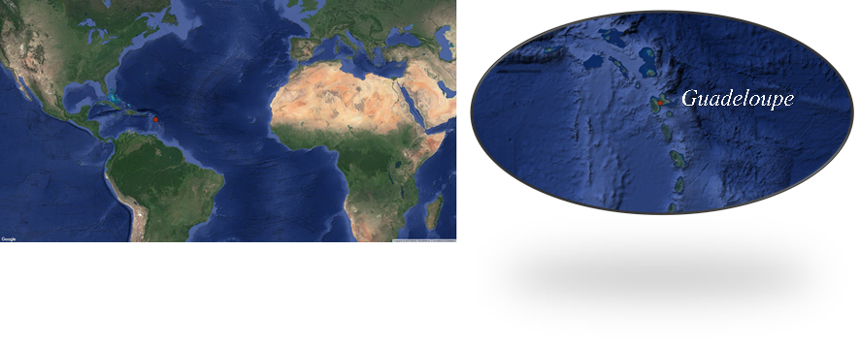

Figure 1: Guadeloupe location 16,24°N, 61,53°W, on the Caribbean arc the city of Pointe à Pitre is depicted by the red point; google satellite (google map, QGIS)

Desert dust is the main natural pollution factor affecting PM10 data in the Caribbean. It permits us to detect the presence of mineral aerosols in the atmospheric layer. In view to assess the spatial and temporal dimension of dust episodes on Caribbean islands (usually 2-4 days), we only selected the daily averages of PM10 data from 2005 to 2015. Such method reduced the impact of anthropogenic pollution which is more likely visible on the hourly measurements (peak of PM10 concentrations between 8 am and 9 am, rush hour).

Previously from 2005 to 2014, the PM10 data were measured by the Pointe-à-Pitre station. Then 2015 PM10 data derived from Baie-Mahault. The whole data set was composed of 3435 valid data (85,5%) and 14,5% of missing data, corresponding to:

-From January and February data in 2013.

-Most of 2014 PM10 measures was invalidated by Gwad'Air network for technical reasons. Only January, February and December data are validated.

-A part of 2011 September data and 2012 December data.

Moreover, the Montserrat volcano (located 50 km at the north west of Guadeloupe archipelago) erupted on 11 February 2010 and rejected some significant amount of ash at high-altitudes. Against trade winds, on the one hand, and the trade winds thereafter, transported volcanic dust particles in the Caribbean and more particularly over Guadeloupe. Volcanic dust particles recirculation in the lower layers of the atmosphere significantly impacted PM10 data for one week. Therefore, 8 days, from February 09 to 16, in 2010 year were not considered in this study, mainly devoted to desert dust events.

Satellite detection related to departure (African coast) and arrival (Guadeloupe, Caribbean region) of the dust plumes presented some features results. It appears that “dust periods” extending on several days can include a starting succession of dusty clouds. Such events can simultaneously result from two main sources: the Saharan region and the Sahelian region. This phenomenon is especially observed on summer (high dust season). Thus, we proposing to identify each dusty day as a dust event individually, similarly to the Prospero et al. study (Propero, et al., 2014).

## Air masses backtrajectories analysis

Backtrajectories are commonly used to examine origin of air masses related to dust events occurring in Europe and the Caribbean area. [ (Stohl, 1998) (Toledano, et al., 2007) (Dunion, 2011) (Prospero, et al., 2014) (Gläser, et al., 2015) (García, et al., 2017)]. For illustrate the seasonal atmospheric circulation, we used the Hybrid Single Particle Lagrangian Integrated Trajectory (HYSPLIT) model version 4 (PC Windows-based HYSPLIT, Unregistered Version Download) provided many possibilities [ (Stein, et al., 2015) (Rolph, et al., 2017)]. NCAR/NCEP global Reanalysis are the meteorological database used as input for HYSPLIT (Kalnay, et al., 1996).

Amongst others, the GIS Shapefiles option permitted to save all the contours for each backtrajectories plot as latitude/longitude positions in an ESRI ArcInfo/ArcView GENERATE format ASCII file which can be imported into the ArcInfo/ArcView GIS program (version QGIS-2.18.14: <http://www.qgis.org/fr/site/>). For backtrajectories simulation, we considered the properties of The Saharan Air Layer (SAL), the layer of dust plumes transport [ (Prospero & Carlson, 1972) (Dunion, 2011)] whish extending generally from 1500 to 5000 m. Thus, chosen altitude of 2000 m, inside the SAL. The starting location is 16,24°N and 61,53°W, at the time 12 UTC, and the duration of 240 hours. So, we have graphically represented all backtrajectories of the days related to the different dust seasons. These illustrated an overall trend targeting the general origin of air masses.

Afterward, we analyzed the ways of transport related to dusty days on a case-by-case assessment. For characterized each backtrajectories, three different altitudes (1500 m, 2000 m and 3000 m) were required for evaluated the stability of routes over the Atlantic Ocean. It permitted to classify air masses pathway. Three distinct Northern Atlantic pathways were identified according to previous study [ (Schutz, 1980) (Dunion, 2011)]:

-North West Atlantic Path (NWAP) trajectory, crossing the Atlantic Ocean between ~10°N and 25°N of latitude. It is the most direct travel connecting African coast to the Caribbean.

-South West Atlantic Path (SWAP) trajectory, further located to the south, less than 10°N of latitude.

-North East Atlantic Path (NEAP) trajectory, coming from the North of America. These kind of air masses made a loop close to African coast, then proceed towards the lesser Antilles. These already have been identified by Dunion (Dunion, 2011) and named as Middle Latitude Dry Air Intrusion (MLDAI).

## Aerosol Optical Thickness (MODIS)

The representation of minerals aerosols distribution over the Atlantic Ocean is illustrated by Aerosol Optical Depth (AOD) imageries [Dark Target, 550 nm (MOD08_M3_v6)] mean of daily mean data computing for seasonal or monthly average maps. It was obtained from the MODerate resolution Imaging Spectroradiometer (MODIS) instrument aboard Terra satellites. We selected one seasonal (DJF: December, January and February) and monthly periods for the years 2005 to 2015, in spatial resolution of 1°. These are available on GIOVANNI (NASA) website (<https://giovanni.gsfc.nasa.gov/giovanni/>). Geographic coordinate of study region: 69,6094 W; 2,1094 E, 29,0625 N.

# Results and analyses

## Analysis of daily mean concentrations of PM10 concentration in Guadeloupe (2005-2015)

The Figure 2 provided behavior of daily average of PM10 concentration in Guadeloupe, for our study period (2005-2015). First, it appears that the most of values are located around 20 µg m-3, that we have identified as the background atmosphere. In rainy condition, the daily PM10 concentrations can be very low (less than 15 µg m-3), due to washing of the atmospheric layer. Furthermore, a periodic increase of the daily concentrations occurring every year, seems to reflect the seasonal dust events. The daily maximum value observed, reached 157,2 µg m-3 on 15 May 2007.

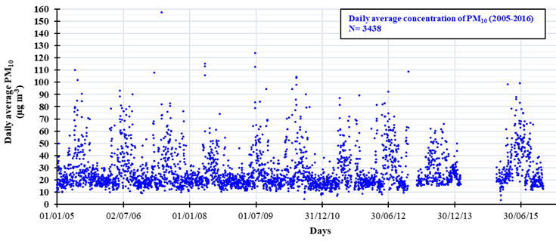

Figure : Daily average of PM 10 for Guadeloupe (2005-2015); Number of data, N=3435

According to the French legislation standards relating to the air quality indexes, for our period of study: 5% of the values linked to very good air, 63% to good air, 10% to medium air, 12% to poor air, 9% to bad air and only 1% to very bad air (Figure 3). Thus, the most of values (about 68%), related to the background atmosphere correspond to good air (index 2) which is specific to Caribbean area exempt of heavy industrial pollution. It appears that human activity and natural pollution due to “sand haze” would have impacted 32% of daily values from 2005 to 2015.

.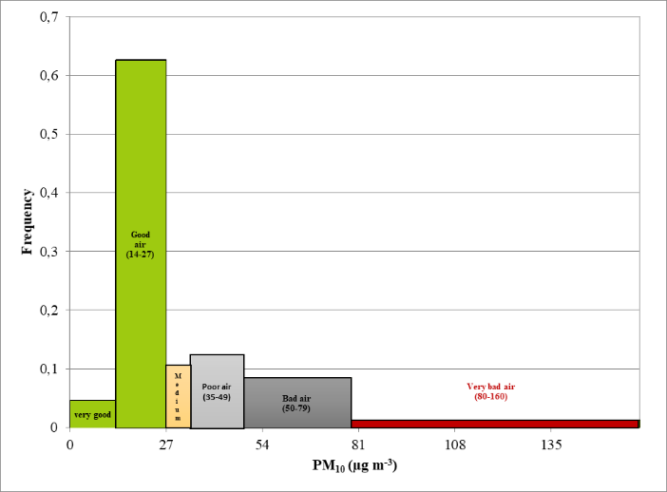

Figure : frequency distribution of PM10 values for Guadeloupe (2005-2015)

### Analysis of WHO guidelines on PM10 concentration in Guadeloupe (2005-2016)

The Figure 4 presents the fluctuations of annual average PM10 concentrations de 2005 à 2015. The results shows that years of 2008, 2009, and 2011 are characterized by low annual values, compared to the others. 2005, 2006, 2007, 2010, 2012 et 2013 can be qualified of intermediates. And 2015 differs of others, with an annual mean concentration clairly upper. WHO recommend do not exceed 20 µg m-3 in annual average PM10 concentrations. Related to desert dust presence in the air masses crossing over Guadeloupe, this limit is every time surpassed (Prospero, et al., 2014).

The European standards guidelines for the protection of health, also impose do not surpassed the threshold of 35 days equal to or greater than 50 µg m-3(in daily mean). This limit is exceeded with a frequency of one time in two for the years between 2005 to 2015 (Figure 5).

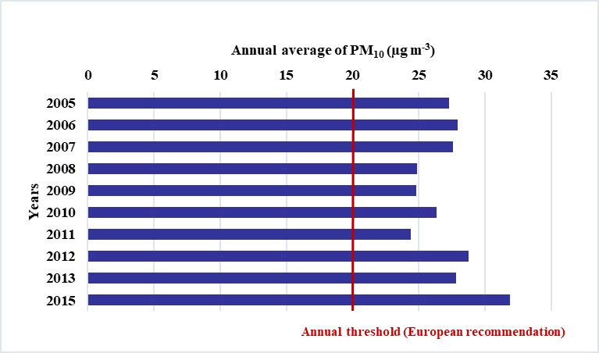

Figure : annual average of PM10 concentrations from 2005 to 2015 (Guadeloupe); WHO recommendation is 20 µg m-3 (red line)

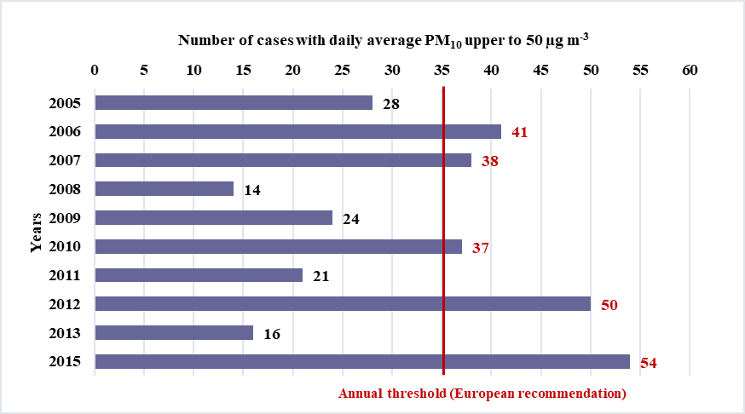

Figure : Number of cases presenting daily average PM10 reaching 50 µg m-3 (red line) per year in Guadeloupe (2005-2016)

In view of the low level of anthropogenic pollution in Caribbean islands, we think that the European PM10 threshold (WHO) related to “sand haze” presence (50 μg m-3) doesn't considers every desert dust events, especially the weak episodes. Therefore, the seasonality of dust events was studied to determine the PM10 threshold and differentiate the “dusty days” from “non-dusty days”. It will be more appropriated for Guadeloupe and Caribbean zone.

## Caribbean desert dust seasons

First, the Figure 6 presents the monthly average of PM10 concentrations from 2005 to 2015. Assuming that dust events are a relatively continuous phenomenon through the year, we propose to define three dust seasons based on monthly mean levels: (1) the low dust season (monthly average less than 20 µg m-3), (2) two intermediates seasons (monthly values between 20 and 30 µg m-3) and (3) the high dust season (monthly values upper to 30 µg m-3).

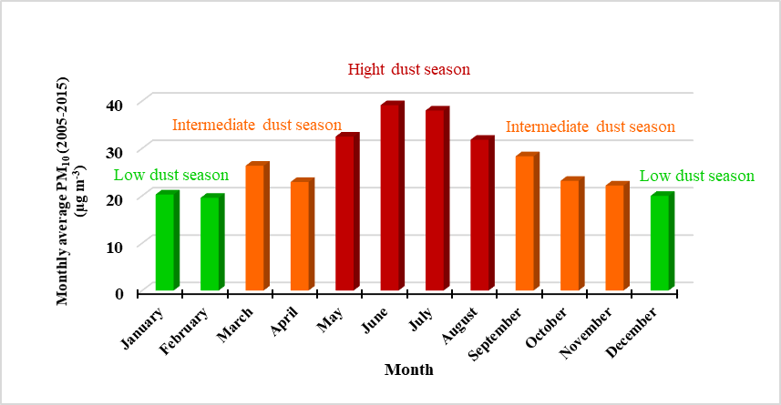



Figure : Monthly averages of PM10 concentrations from 2005 to 2015 (Guadeloupe) and monthly standard deviation (table below); Low dust season for December to February (in green); Intermediates dust season for March and April, and September to November (in orange); High dust season for May to August (in red)

Thus, we characterized each kind of dust seasons by the frequency distribution of PM10 concentrations (Figure 6). The values are divided by class corresponding to air quality ranges presented in Table 1. The first class, starting from 0 up to 34 μg m-3, corresponds to good air quality days; The second one, between 35 and 49 μg m-3, relates to poor air quality; the class from 50 μg m-3 to 79 µg m-3 qualified as bad air quality; and the values upper to 80 µg m-3 are defined as very bad situations and related to strong desert dust events.

Table : Air quality indexes (French legislation)

|  |  |  |  |  |
| --- | --- | --- | --- | --- |
| **Air quality** | **0-34 µg m-3**  **Good air quality** | **35-49 µg m-3**  **Poor air quality** | **50-79 µg m-3**  **Bad air quality** | **80 µg m-3**  **Very bad air quality** |
| **Indexes** | **1** | **2** | **3** | **4** |

During the low dust season (Figure 7a), 83% of PM10 concentrations belong to the second class (from 15 to 35 μg m-3), and 15% of values are part of the first one (lower than 35 μg m-3). Less than 2% are upper to 50 μg m-3.

For the high dust season (Figure 7b), 57% of values are distributed into the two first class. Then, 23% are associated to the third class and 16% in class four. And finely, 3% of cases belong to the last range, the very bad air quality (PM10 ≥ 80 μg m-3). It appears a contrast between the distribution of PM10 data during high and low dust seasons. In general, it appears that the air quality deteriorates significantly for the period of MJJA whereas for MA, the good air prevails.

The two intermediate seasons (Figure 7c and 7d), presents a similar behaviour: about 85% of PM10 concentrations are linked to good air and 14% to bad air. Fewer of 1% cases correspond to very bad air.

Overall, for any dust seasons, the mostly PM10 concentrations grouped into the second class (15-35 μg m-3). Which express that this one includes the background atmosphere level specific to Guadeloupe. And the distribution of values related to the third and the fourth classes, seems to characterize each dust seasons. Very bad air quality usually occurs only very rarely.

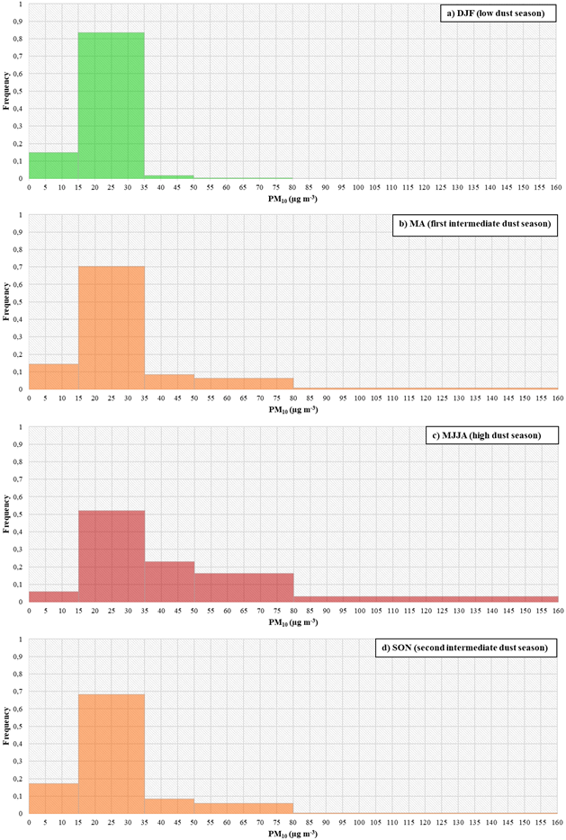

Figure : Frequency distribution of PM10 concentration according to the different dust seasons DJF (a) low dust season), MJJA (c) high dust season and MA SON (b) and (d) Intermediates dust season)

### Dusty days threshold

To determine the threshold concentration of a dusty day for Guadeloupe, we used the low dust season, December, January and February (DJF) that shows a weak standard deviation (Figure 6, table). The distribution of DJF PM10 data set (N=848) is represented by the Figure 8 by means of the percentile values. 75 % of values are less than 22 µg m-3 (anthropogenic pollution) and 90% are inferiors to 27,5 µg m-3. The graph clearly shows some distinct characteristic slopes involving different phenomena. Rainy conditions could explain values below 14 µg m-3 (percentile 10%), due to moist tropical Caribbean climate, that generates very weak quantities of particles in lower layer of the atmospheric (washing). A second trend emerge for the values between 14 to 27,5 µg m-3 (respectively percentile 10% to 90%), and seems to reflect the dominant anthropogenic pollution linked to human activities. Then, a third trend appears after 27,5 µg m-3 (percentile 90%) which could be linked to punctual anthropogenic pollution increases or a geostrophic pollution related to some rare dust events can producing during this period. The maximum value (100% percentile) is 61,8 µg m-3.

To separate these two factors impacting daily PM10 concentration, we finely examined slope steepness. we used the rate of increase method to target a potential change slope between the highest 10% of values (90% to 100% percentiles). That is to calculate the quotient difference in ordinate (∆y) on the difference in abscissa (∆x) corresponding [ (Zandieh, 2000) (Wagner, et al., 2015)] calculated as the following expression:

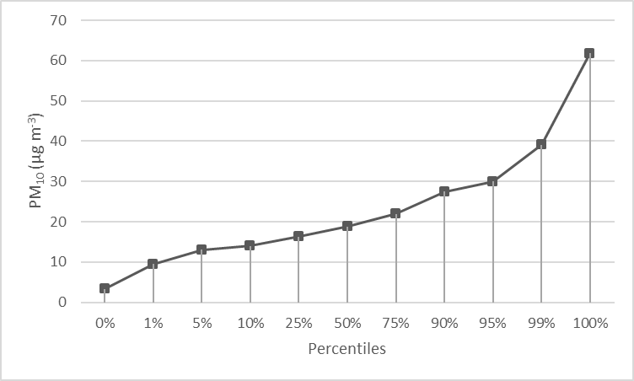

Figure : PM10 values corresponding to percentile level for DJF period (2005-2015)

Thus, the Figure 9 brings to light the deviation between percentiles values from 90% to 99%. The apparent jump after the percentile 97% (PM10 values upper than 32,3 µg m-3) reflects a significant transition of pollution events. Without excluding some possible errors of measurements might be involved, our hypothesis is the following: the rare values exceeding 34 µg m-3 threshold (only 2%), correspond to punctual dust events occurs in low dust season. This express that the highest impacts related to anthropogenic pollution can relatively reach between ~32 and 34 µg m-3. Consequently, considering the other predominant factor affected air quality, the "sand haze" phenomenon, we proposed to set the threshold of “dusty day” at **35 µg m-3** in daily concentration. It’s also corresponds to the start of poor air quality index setting by French legislations (Table 1).

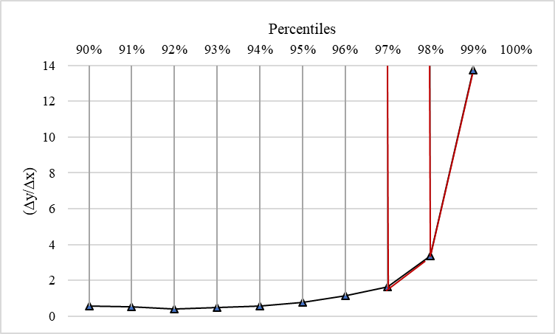

Figure : (∆y/∆x) corresponds to the difference quotient related to deviation percentile values PM10 (2005-2015)

Thus, in application with this new threshold of “dusty days” for Guadeloupe, the Figure 10 illustrates the average number associated to dusty events, according to the dust season previously defined by monthly average. It emerges that monthly mean number of dusty days cases better highlight the different dust seasons than monthly average. The significant increase of number related to sand haze phenomenon through months also reflect the seasonality variation of dust events. Thus, DJF counts less than one dust event, MJJA between nine to sixteen dusty cases and MA SON less than 6 dusty day on average. It appears for intermediates dust seasons, that the standard deviations values are rather important. This observation supports the punctual nature of dust events at this period.

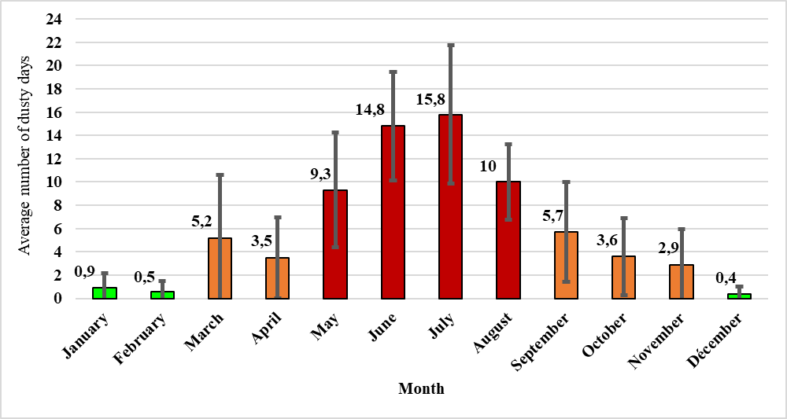

Figure : monthly mean number of dusty days (2005-2015) for Guadeloupe; error bar illustrate the monthly standard deviation

### Characterizations of seasonal dust events

This section itemizes the monthly analysis according to the PM10 concentration fluctuation combined to the origin of air masses (backtrajectories) and to AOT satellite imageries (MODIS). First, the classic cases are presented: the low and the high dust seasons. Then the two intermediates seasons that shows a special behavior.

The Low dust season; December, January and February (DJF)

AOT satellite detection on Atlantic Ocean shows that DJF is the lowest period of dust for Caribbean center (Figure 11). However, this does not exclude possibility of punctual dust events may occur. Since the dust reservoirs of Africa are relatively active all year round [ (Schutz, 1980) (Ben-Ami, et al., 2012) (Prospero, et al., 2014)], it is the North Atlantic zone atmospheric circulation plays a key role in the export of mineral aerosols toward Caribbean.

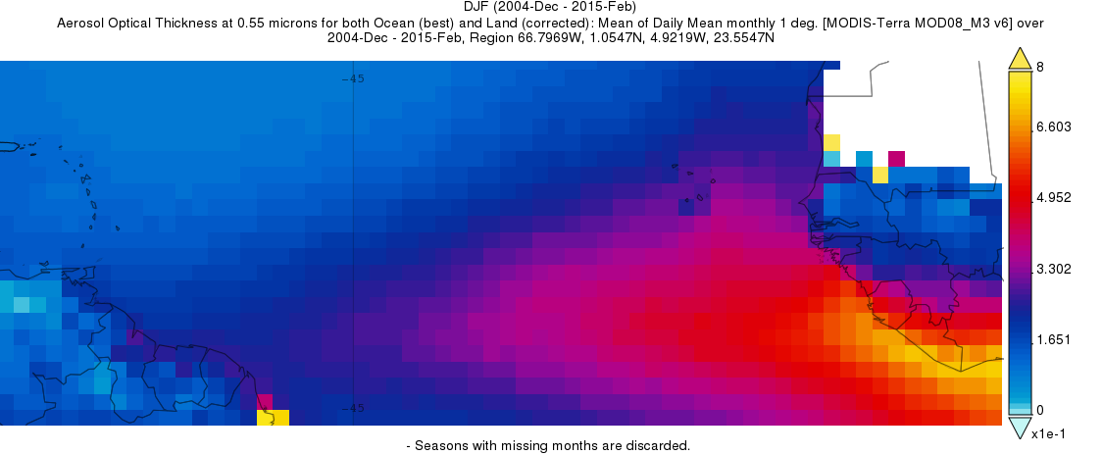

Figure : seasonal average (DJF) of Optical Aerosol Optical Thickness (2005-2015) provided by satellite image processing from MODIS

During DJF, air masses mainly come from to the north America (Figure 12). These have been previously identified by Dunion in 2011 (Dunion, 2011), who appointed them MidLatitude Dry Air Intrusions (MLDAIs). Only a few backtrajectories originate from African coast (Figure 10). Global Atmospheric circulation over north Atlantic and south position of ITCZ (Adams, et al., 2012) (Ben-Ami, et al., 2012) (Prospero, et al., 2014), are not propitious for desert dust transport to Caribbean region. It is the reason why this period presents weak monthly PM10 concentrations for Guadeloupe.

So, dust events are exceptional due to the air masses type (MLDAI) (Dunion, 2011). It does not favour the transport of “sand haze” to the Caribbean area. However, very rare cases of dust events are observed during this season.

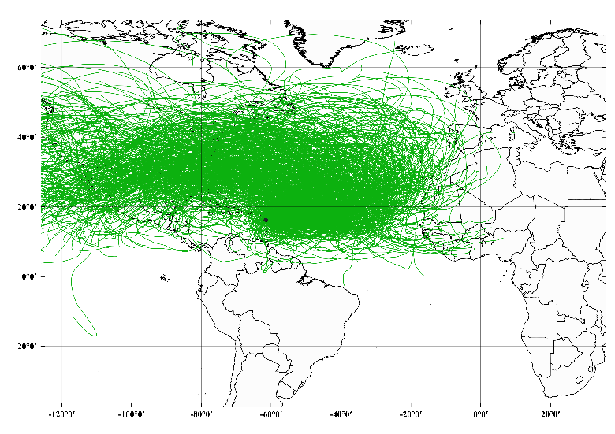

Figure : Backtrajectories for each days of DJF from 2005 to 2015; Backtrajectories are generate by Hysplit Model (downloaded version) then integrated into the QGIS 2.18.14 geolocation software with the following configurations: Start location (point): latitude 16,24°N, longitude -61,53°W; Altitude: 2000 m and duration:240 hours; N=1112 backtrajectories

High Dust Season (MJJA): May to August

Under previous studies, June, July and August identified as the high dust season for Caribbean zone [ (Schutz, 1980) (Brooks & Legrand, 2000) (Adams, et al., 2012) (Prospero, et al., 2013) (Propero, et al., 2014) and others]. In our statistic monthly analyze of PM10 concentrations, we added May to the high dust season. In accordance with monthly PM10 concentrations (Figure 6), June and July present the higher AOT on the satellite detection imageries (Figure 13). May and August reflect the beginning and the end of high dust season with slightly weaker AOT values but still important.

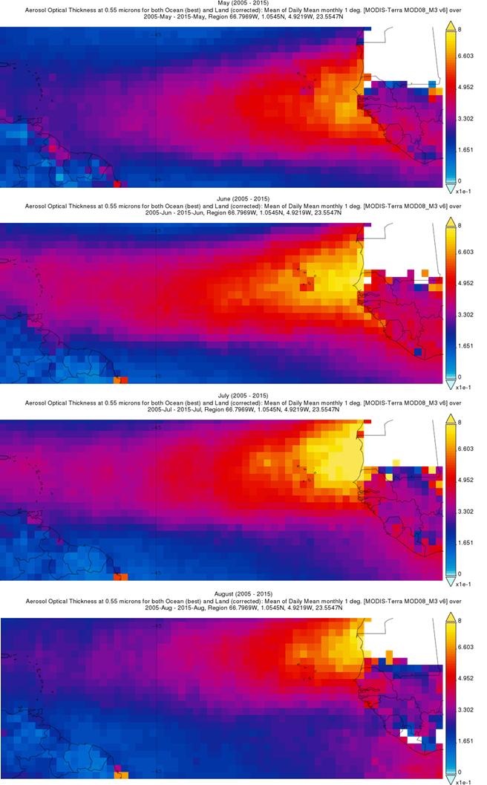

Figure : seasonal average (MJJA) of Optical Aerosol Optical Thickness (2005-2015) provided by satellite image processing from MODIS

For these months, air masses mostly come from Africa (Figure 14), therefore, strong AOT and PM10 concentrations in Caribbean islands during MJJA.

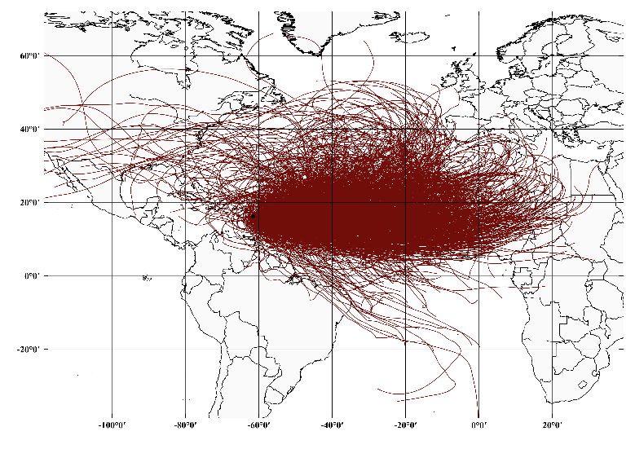

Figure : Backtrajectories for each day of MJJA from 2005 to 2015; Backtrajectories are generate by Hysplit Model (downloaded version) then integrated into the QGIS 2.18.14 geolocation software with the following configurations: Start location (point): latitude 16,24°N, longitude -61,53°W; Altitude: 2000 m and duration:240 hours; N=1352 backtrajectories.

Intermediate dust seasons: March and April (MA)

MA corresponds to the first intermediate dust season. This is characterized by an important monthly means number of dusty days between years (Figure 10). Previous study shows that the dust plumes transport at this period presented special pathway (Euphrasie-Clotilde, et al., 2015). During spring, the predominate source activity of Sahelian zone (Bodélé) usually affects the South of America (Guyana, Amazonia) (Propero, et al., 2014). Indeed, the seasonal fluctuation of ITCZ position favors a southern transport. For some years, it sometimes occurs that dust air masses affect South America then wind up West Indies arc to reach Guadeloupe (center of the arc). Barbados (south of the arc) are more commonly impacted by these spring dust season. The seasonal AOT detection doesn't adequately convey this distinctive dust events (Figure 15), nevertheless, they are recurring on several years.

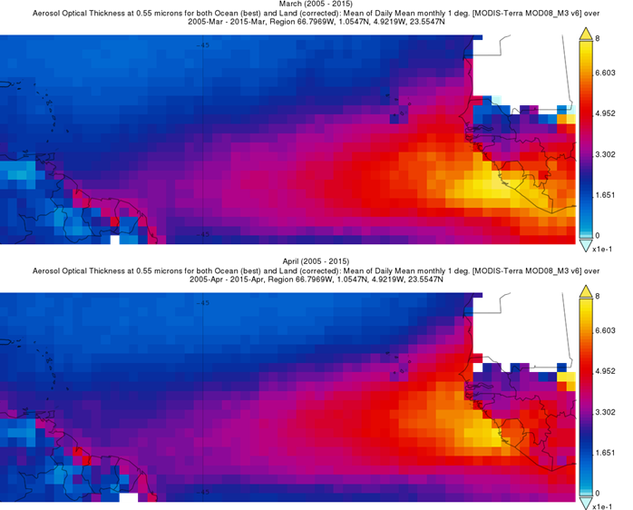

Figure : seasonal average (MA) of Optical Aerosol Optical Thickness (2005-2015) provided by satellite image processing from MODIS

Backtrajectories analysis (Figure 16) presented multiple main origins: African coast (associated to a southern transport), Europe and the North America. Currently, the Atmospheric circulation over the Atlantic Ocean describes a transition atmosphere between the low and high dust season.

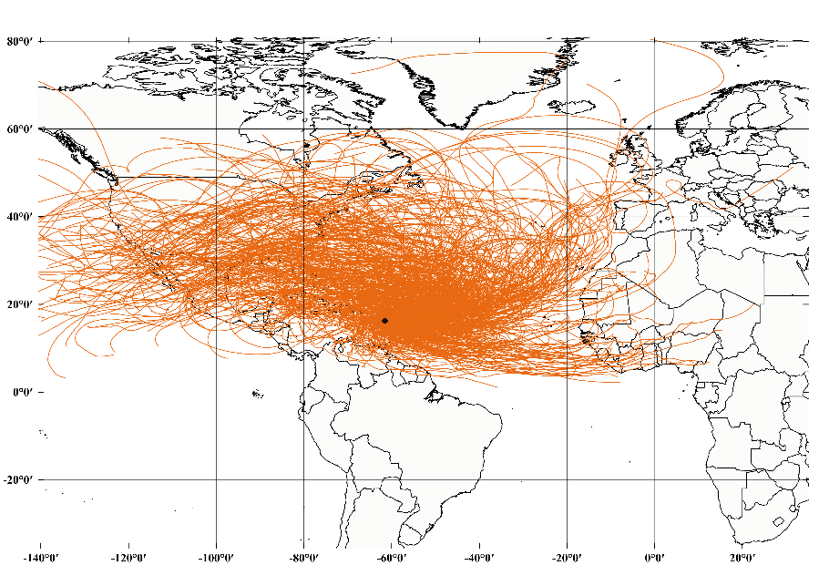

Figure : Backtrajectories for each days of MA from 2005 to 2015; Backtrajectories are generate by Hysplit Model (downloaded version) then integrated into the QGIS 2.18.14 geolocation software with the following configurations: Start location (point): latitude 16,24°N, longitude -61,53°W; Altitude: 2000 m and duration:240 hours; N=655 backtrajectories

### Second intermediate season: September to November (SON)

The second intermediates season, SON, presents the same fluctuation characteristics throughout years. However, the transport process associated differ. AOT detection satellite describes three behaviours between September to November (Figure 17). On the one hand, dust events are more frequent in September whish presents the higher AOT occurrence. November and October show the lower monthly AOT values, which agrees with the results of the study of Ben Ami et al. (Ben-Ami, et al., 2012). Moreover, for September, the departure of dust cloud located mostly to the North of African coast.

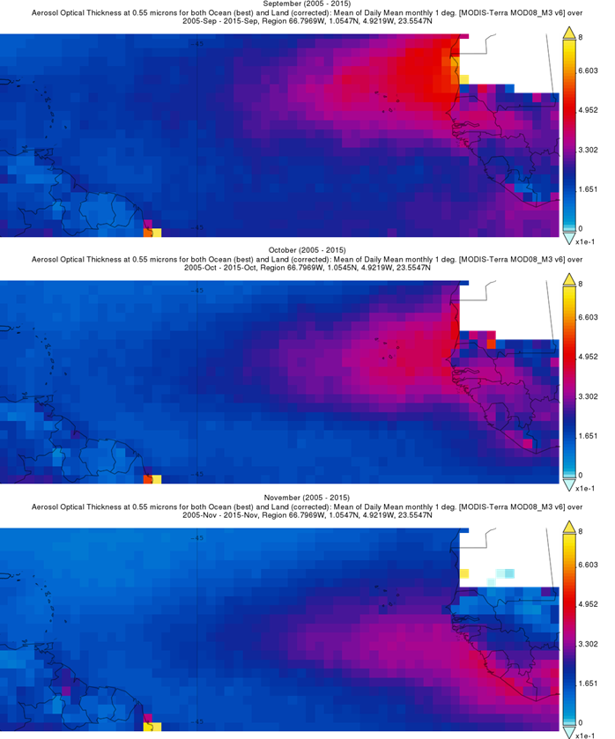

Figure : seasonal average (SON) of Optical Aerosol Optical Thickness (2005-2015) provided by satellite image processing from MODIS

The Backtrajectories show some similarity with the standard air masses pathway during high dust season transport (Figure 18). In addition, the southern Atlantic Ocean route, and the North America origin also emerge. This is also a transition atmosphere circulation.

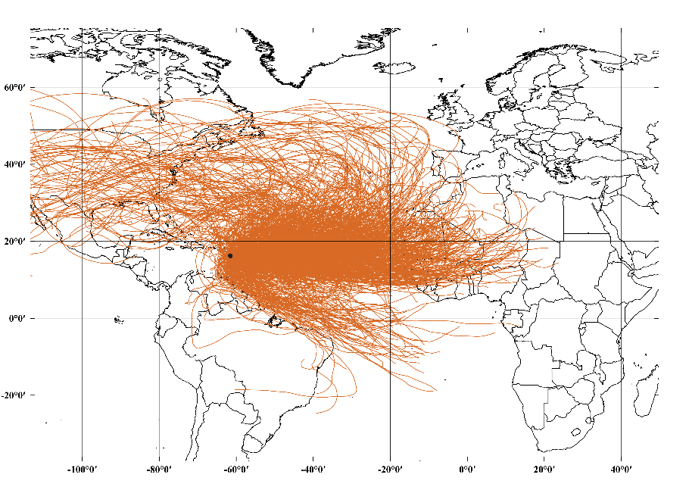

Figure : Backtrajectories for each days of SON from 2005 to 2015; Backtrajectories are generate by Hysplit Model (downloaded version) then integrated into the QGIS 2.18.14 geolocation software with the following configurations: Start location (point): latitude 16,24°N, longitude -61,53°W; Altitude: 2000 m and duration:240 hours; N=995 backtrajectories

### 3.2.3 Atlantic road related to dusty air masses

Ultimately, we studied the route of individual air masses associated with dusty days (daily PM10 concentrations equal or upper than 35 µg m-3) considering three levels of transport layer (1500 m, 2000 m and 3000 m). This method allowed us to evaluate the stability of retro as a function of altitude. Thus, three types of route were identified: (1) NWAP (15 to 25° N), (2) SWAP (5 to 15° N) and (3) NEAP (North America origin). NEAP linked to MLDAI air masses, seeded by desert dust particles in altitude over the Atlantic Ocean. When they made a loop close to African coasts and they brought desert dust particles moving toward Caribbean area (Euphrasie-Clotilde et al, 2016). Moreover, multiple road for different altitudes was also referenced. Tropical waves on the road of dust air masses commonly impact the backtrajectories representation and it can be associated to undetermined (inconsistent trace). The backtrajectories of pure (three altitudes) North origin associated to dusty days, could be indicate some measurement errors or exceptional anthropic pollution peak. As example, the Figure 19 presents the different route taken by the “potential” dust air masses.

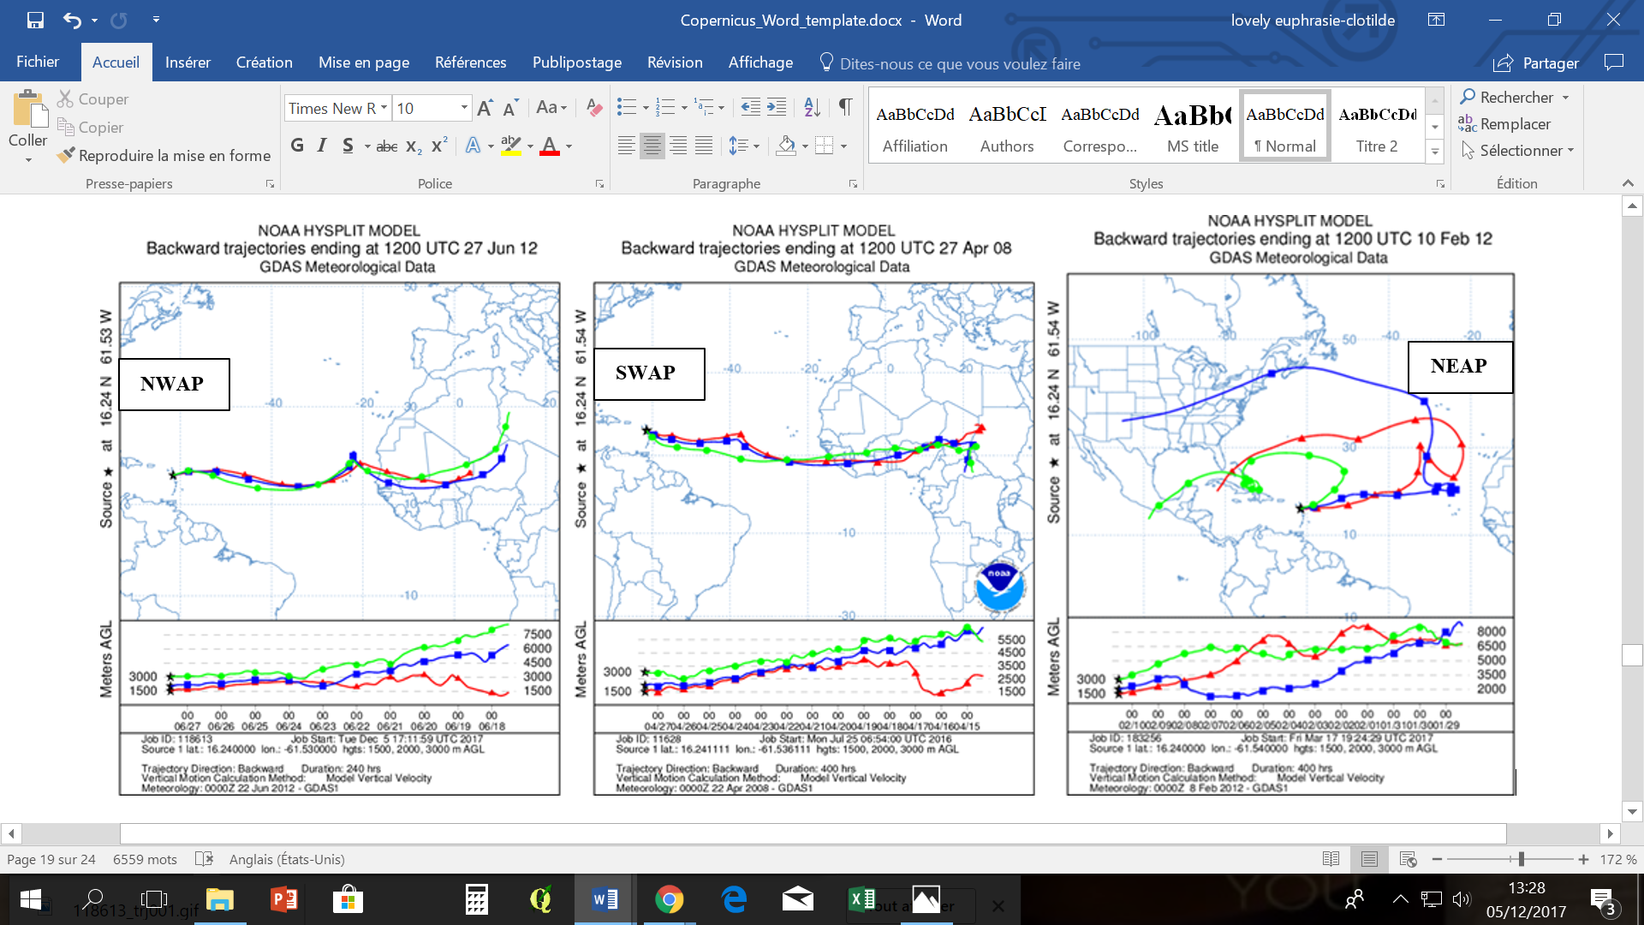

Figure : Tranport road usually associated to dusty days (2005-2015)

The Figure 20 (combined with the Table 2) shows that High (MJJA) and second intermediate (SON) dust events usually associated to NWAP route for over 50% of dust cases. The SWAP route, least common way, occurs most often on MA (23,3%) of but also on MJJA at 23,4%. NEAP route mainly concerns the first part of the year, DJF and MA with respectively 46,7% and 24,4%. Multiple origin cases mostly occur in DJF. We considered that the multiple origin cases could be reflect a significant instability of atmosphere circulations. There is a possibility of multiple input of several dust air masses converging on Atlantic Ocean. But it can' t really attested because of the incertitude degree linked to HYSPLIT model. About 10% of cases are undetermined (inconsistent trace) and just under 6% are linked to pure north route.

Our analysis based on backtrajectories permitted us to illustrate the annual atmospheric cycle circulation of dusty air masses:

-NEAP cases are very common from December to February (DJF), then decrease progressively in MA. during MJJA, they are very rare and reappear during SON

-In contrast, NWAP cases are less frequent at the beginning of the year (DJF and MA) and then dominate in MJJA and SON

-SWAP cases, which are generally less common, occur most frequently in MA and MJJA. These are rarer in DJF and SON

-And Multiples routes seems occurs mainly during DJF. The other period MJJA and SON also show instability trace arguably coinciding with the hurricane season (tropical wave…).

Thus, this cycle of transport controls the seasonal activity of dust events in a part of Caribbean arc (Guadeloupe).

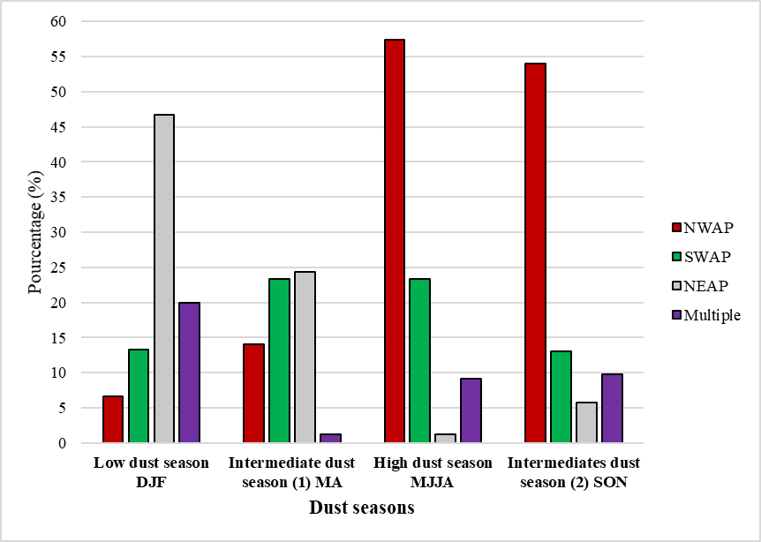

Figure : characterization of routes associated to Guadeloupe seasonal dust events (2005-2015)

Table

|  |  |  |  |  |  |  |
| --- | --- | --- | --- | --- | --- | --- |
|  | N. Days | N. dusty days  (%) | NWAP  (%) | SWAP  (%) | NEAP  (%) | Multiple  (%) |
| Low dust season | 848 | 15 (1,8%) | 1(6,7%) | 2(13,3%) | 7(46,7%) | 3(20%) |
| Intermediate dust season (1) | 562 | 86 (15,3%) | 12(14%) | 20(23,3%) | 21(24,4%) | 1(1,2%) |
| High dust season | 1184 | 500 (43,6%) | 287 (57,4%) | 117(23,4%) | 6(1,2%) | 46(9,2%) |
| Intermediates dust season (2) | 841 | 122 (14,5%) | 66 (54%) | 16(13,1%) | 7(5,7%) | 12(9,8%) |

# Discussion

# Conclusion

# Acknowledgment

# References

# Bibliographie

Adams, A. M., Prospero, J. M. & Zhang, C., 2012. CALIPSO-derived three-dimensional structure of aerosol over the Atlantic Basin and adjacent continents. *Journal of Climate,* Volume 25, pp. 6862-6879.

Ben-Ami, et al., 2012. Discernible rhythm in the spatio/temporal distributions of transatlantic dust. *Atmospheric Chemistry and Physics,* 12(5), pp. 2253-2262.

Ben-Ami, et al., 2010. Transport of North African dust from the Bodélé depression to the Amazon Basin: a case study. *Atmospheric Chemistry and Physics,* 10(16), pp. 7533-7544.

Blackadar, 1957. Boundary layer wind maxima and their significance for the growth of nocturnal inversions. *Bull. Amer. Meteor. Soc,* Volume 38, pp. 283-290.

Bou Karam, D., 2008. *Mecanismes de soulevement dáerosols desertiques en Afrique de lÓuest,* s.l.: s.n.

Brooks & Legrand, 2000. *Dust variability over northern Africa and rainfall in the Sahel.* s.l.:s.n.

Cadelis, G., Tourres, R. & Molinié, J., 2014. Short-term effects of the particulate pollutants contained in saharan dust on the visits of children to the emergency department due to asthmatic conditions in Guadeloupe (French Archipelago of the Caribbean). *PloS one*, 6 Mars, 3(9), p. e91136.

Chiapello, I. et al., 1997. Origins of African dust transported over the northeastern tropical Atlantic. *Journal of Geophysical Research: Atmospheres,* Volume 102, pp. 13701-13709.

Chiapello & Moulin, 2002. TOMS and METEOSAT satellite records of the variability of Saharan dust transport over the Atlantic during the last two decades (1979-1997). *Geophysical Research Letters,* 29(8).

Clergue, et al., 2015. Influence of atmospheric deposits and secondary minerals on Li isotopes budget in a highly weathered catchment, Guadeloupe (Lesser Antilles). *Elsevier.*

Coudé-Gaussen, G., 1991. *Les poussières sahariennes.* s.l.:s.n.

Coz, et al., 2009. Individual particle characteristics of North African dust under different long-range transport scenarios. *Atmospheric Environment,* 43(11), pp. 1850-1863.

d'Almeida, 1986. A model for Saharan dust transport. *Journal of climate and applied meteorology,* 25(7), pp. 903-916.

Declercq, et al., 2012. *Impact sanitaire de la pollution altmosphérique dans neuf villes françaises, Résultats du projet Aphekom,* Saint-Maurice : Institut de veille sanitaire: s.n.

Dunion, J. P., 2011. Rewriting the climatology of the tropical North Atlantic and Caribbean Sea atmosphere. *Journal of Climate,* Volume 24, pp. 893-908.

Engelstaedter & Washington, 2007. Atmospheric controls on the annual cycle of North African dust. *Journal of geophysical research atmospheres,* 112(D03103).

Euphrasie-Clotilde, et al., 2015. *EGU2015-14727 | Posters | AS3.10.* Vienne, s.n.

Flamant, C. P. T. C. B. T. P., 2007. Airborne observations of the impact of a convective system on the planetary boundary layer thermodynamics and aerosol distribution in the inter-tropical discontinuity region of the West African monsoon. *Quarterly Journal of the Royal Meteorological Society,* 133(626), pp. 1175-1189.

Formenti, S. B. D. E. K. P. S. W. Z., 2011. Recent progress in understanding physical and chemical properties of African and Asian mineral dust. *Atmospheric Chemistry and Physics,* 11(16), pp. 8231-8256.

García, M. I., Rodríguez, S. & and Alastuey, A., 2017. Impact of North America on the aerosol composition in the North. *Atmospheric Chimistry and Physics ,* June, 17(12), p. 7387.

Ginoux, et al., 2001. Sources and distributions of dust aerosols simulated with the GOCART model. *Journal of geophysical research,* 16 Septembre, Volume 106, p. 20255–20273.

Gläser, Wernli, Kerkweg & Teubler, 2015. The transatlantic dust transport from North Africa to the Americas—Its characteristics and source regions. *Journal of Geophysical Research: Atmospheres,* pp. 231-252.

Goudie & Middleton, 2001. Saharan dust: sources and trajectories. *Transactions of the Institute of British Geographers,* 26(2), pp. 165-181.

Huang, Zhang & Prospero, 2010. African dust outbreaks: A satellite perspective of temporal and spatial variability over the tropical Atlantic Ocean. *Journal of Geophysical Research: Atmospheres,* 115(D5).

Institut de veille sanitaire, 2012. *Note de synthèse relative à la problématique des vents de sable en provenance des déserts,* s.l.: s.n.

Kalnay, E. et al., 1996. The NCEP/NCAR 40-year reanalysis project. *Bulletin of the American meteorological Society,* 77(3), pp. 437--471.

Kaufman, Y. J. et al., 2005. Dust transport and deposition observed from the Terra-Moderate Resolution Imaging Spectroradiometer (MODIS) spacecraft over the Atlantic Ocean. *Journal of Geophysical Research: Atmospheres,* Volume 110.

Koren, I., Joseph, J. H. & Israelevich, P., 2003. Detection of dust plumes and their sources in northeastern Libya. *Canadian journal of remote sensing,* 29(6), pp. 792--796.

Koren, et al., 2006. The Bodele depression: a single spot in the Sahara that provides most of the mineral dust to the Amazon forest. *Environmental Research Letters,* 1(1).

Longueville, D., Henry & Ozer, 2009. Saharan dust pollution: Implications for the Sahal?. *Epidemiology,* 20(5), p. 780.

Monteil, M. et al., 2005. Comparison of prevalence and severity of asthma among adolescents in the Caribbean islands of Trinidad and Tobago: results of a nationwide cross-sectional survey. *BMC Public Health*, 5(1), p. 96.

Petit, R. et al., 2005. Transport of Saharan dust over the Caribbean Islands: Study of an event. *Journal of Geophysical Research: Atmospheres*, 110(D18).

Plocoste, Calif & Jacoby-Koaly, 2017. Temporal multiscaling characteristics of particulate matter PM10 and ground-level ozone O3 concentrations in Caribbean region. *Atmospheric Environment.*

Propero, J. M., Collard, F.-X., Molinié, J. & Jeannot, A., 2014. Characterizing the annual cycle of African dust transport to the Caribbean Basin and South America and its impact on the environment and air quality. *Global Biogeochemical Cycles*, 28(7), pp. 757--773.

Prospero, Blades, Mathison & Naidu, 2005. Interhemispheric transport of viable fungi and bacteria from Africa to the Caribbean with soil dust. *Aerobiologia,* 21(1), pp. 1-19.

Prospero, et al., 2008. Relationship between African dust carried in the Atlantic trade winds and surges in pediatric asthma attendances in the Caribbean. *International journal of biometeorology,* 52(8), p. 823.

Prospero, Collard & Jeannot, J. M. a., 2014. Characterizing the annual cycle of African dust transport to the Caribbean Basin and South America and its impact on the environment and air quality. *Global Biogeochemical Cycles,* 28(7), pp. 757-773.

Prospero, Glaccum & Nees, 1981. Atmospheric transport of soil dust from Africa to South America. *Nature,* 289(5798), pp. 570--572.

Prospero, J. M., Bonatti, E., Schubert, C. & Carlson, T. N., 1970. Dust in the Caribbean atmosphere traced to an African dust storm. *Earth and Planetary Science Letters,* 9(3), pp. 287-293.

Prospero, J. M. & Carlson, T. N., 1972. Vertical and areal distribution of Saharan dust over the western equatorial North Atlantic Ocean. *Journal of Geophysical Research,* Volume 77, pp. 5255-5265.

Prospero, J. M. et al., 2002. Environmental characterization of global sources of atmospheric soil dust identified with the Nimbus 7 Total Ozone Mapping Spectrometer (TOMS) absorbing aerosol product. *Reviews of geophysics,* Volume 40.

Prospero, Mayol-Bracero & Olga, 2013. Understanding the transport and impact of African dust on the Caribbean basin. *Bulletin of the American Meteorological Society,* 94(9), pp. 1329-1337.

Reid, J. S. et al., 2003. Analysis of measurements of Saharan dust by airborne and ground-based remote sensing methods during the Puerto Rico Dust Experiment (PRIDE). *Journal of Geophysical Research: Atmospheres,* Volume 108.

Rolph, G., Stein, A. & and Stunder, B., 2017. Real-time Environmental Applications and Display sYstem: READY. *Environmental Modelling & Software,* Volume 95, pp. 210-228.

Schepanski, K. et al., 2009. Meteorological processes forcing Saharan dust emission inferred from MSG-SEVIRI observations of subdaily dust source activation and numerical models. *Journal of Geophysical Research: Atmospheres,* Volume 114.

Schepanski, K., Tegen & Macke, A., 2009. Saharan dust transport and deposition towards the tropical northern Atlantic. *Atmospheric Chemistry and Physics,* Volume 9, pp. 1173-1189.

Schutz, L., 1980. Long range transport of desert dust with special emphasis on the Sahara. *Annals of the New York Academy of Sciences,* Volume 338, pp. 515-532.

Schwanghart & Schutt, 2008. Meteorological causes of Harmattan dust in West Africa. *Geomorphology,* 95(3), pp. 412-428.

Stein, A. et al., 2015. NOAA's HYSPLIT atmospheric transport and dispersion modeling system. *Bull. Amer. Meteor. Soc.,* Volume 99, pp. 2059-2077.

Stohl, A., 1998. Computation, accuracy and applications of trajectories—a review and bibliography. *Atmospheric Environment,* 32(6), pp. 947--966.

Todd, et al., 2007. Mineral dust emission from the Bodélé Depression, northern Chad, during BoDEx 2005. *Journal of Geophysical Research: Atmospheres,* 112(D6).

Toledano, C. et al., 2007. Inventory of African desert dust events over the southwestern Iberian Peninsula in 2000--2005 with an AERONET Cimel Sun photometer. *Journal of Geophysical Research: Atmospheres,* 112(D21).

Wagner, J. F. et al., 2015. *An Extended Theoretical Framework for the Concept of the Derivative.* s.l., s.n.

Washington, et al., 2009. Dust as a tipping element: the Bodélé Depression, Chad. *Proceedings of the National Academy of Sciences,* 106(49), pp. 20564-20571.

Washington & Todd, 2005. Atmospheric controls on mineral dust emission from the Bodélé Depression, Chad: The role of the low level jet. *Geophysical Research Letters,* 32(17).

Zandieh, M., 2000. A theoretical framework for analyzing student understanding of the concept of derivative. *CBMS Issues in Mathematics Education,* Issue 8, p. 103–122.

Zender, C. S., Bian, H. & Newman, D., 2003. Mineral Dust Entrainment and Deposition (DEAD) model: Description and 1990s dust climatology. *Journal of Geophysical Research: Atmospheres,* Volume 108.



Figure : The logo of Copernicus Publications.